**SECTION 2 : DATA HANDLING USING PANDAS**

**2.** To Create Pandas Series using List & ndarray.

**Date: 19.10.20**

**Program No: 1**

**1.** To create Pandas Series and display its attributes.

**Aim:**

A Python list namely **section** stores the section names (‘A’ ,’B’ ,’C’ ,’D’ ) of class 12. Another list **contri** stores the contribution (6700, 5600, 5000, 5200) made by students to a charity fund. Write code to create a Series object that stores the contribution amount as the values and the section names as the indexes. Also print its attributes.

|  |  |
| --- | --- |
| **Source Code:**  import pandas as pd  section=['A','B','C','D']  contri=[6700,5600,5000,5200]  s=pd.Series(data=contri,index=section)  print("Series is:")  print(s)  print("Attributes:")  print("Data Type:",s.dtype)  print("Shape:",s.shape)  print("No. of bytes:",s.nbytes)  print("No. of Dimensions:",s.ndim)  print("Has NaNs:",s.hasnans)  print("Empty:",s.empty) | **Output:** |

**2.** To Create Pandas Series Using List & ndarray.

**Program No: 2**

**Date: 20.10.20**

**Aim:**

Write a menu driven program in python to create pandas series using the following menu:

**\*\*\*\*\*\*MENU \*\*\*\*\*\*\*\***

**1. Series using a list**

**2. Series using nd array**

**Source Code:**

import pandas as pd

import numpy as np

print("******MENU*******")

print("1. Series using a List")

print("2. Series using nd array")

c=int(input("Enter ur choice"))

if c==1:

a=list()

n=int(input("Enter the size of the list"))

print("Enter the numbers in the list")

for i in range(0,n):

num=int(input("Enter number:"))

a.append(num)

print("The series from the given list is ")

s=pd.Series(a)

print(s)

elif c==2:

st=int(input("enter the starting range"))

et=int(input("enter the ending range"))

s=pd.Series(np.arange(st,et))

print("The series from the given nd array is ")

print (s)

else:

print ('Invalid choice')

**Output:**

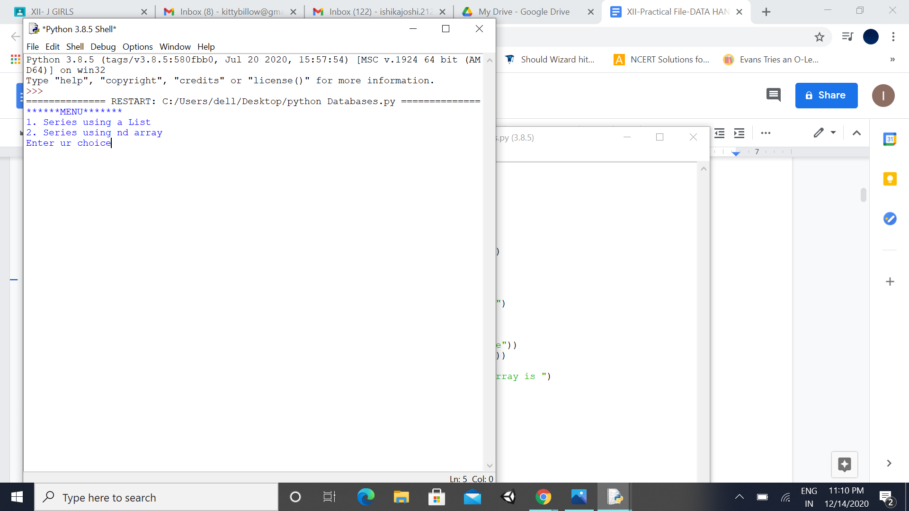

**3.** To Create Pandas Series using Dictionary & Scalar Value.

**Program No: 3**

**Date: 21.10.20**

**Aim:**

Write a menu driven program in python to create pandas series using the following menu:

**\*\*\*\*\*\*MENU \*\*\*\*\*\*\*\***

**1. Series using a dictionary**

**2. Series using a scalar value**

**Source Code:**

import pandas as pd

import numpy as np

print("******MENU*******")

print("1. Series using a dictionary")

print("2. Series from a scalar value")

c=int(input("Enter ur choice"))

if (c==1):

a=list()

n=int(input("Enter the size of the dictionary"))

print("Enter the elements of the dictionary")

for i in range(0,n):

num=input("Enter an element:")

a.append(num)

b=list()

print("Enter the key values of the dictionary")

for i in range(0,n):

num1=input("Enter the key:")

b.append(num1)

print ("The dictionary is ")

mydi=dict(zip(a,b))

print (mydi)

s=pd.Series(mydi)

print ("The series is")

print(s)

elif(c==2):

value=int(input("Enter the scalar value from which the series is to be created"))

n=int(input("Enter the required size for series:"))

index=(np.arange(n))

s=pd.Series(value,index)

print("The series from the given constant is ")

print (s)

else:

print('invalid choice,try again')

**Output:**

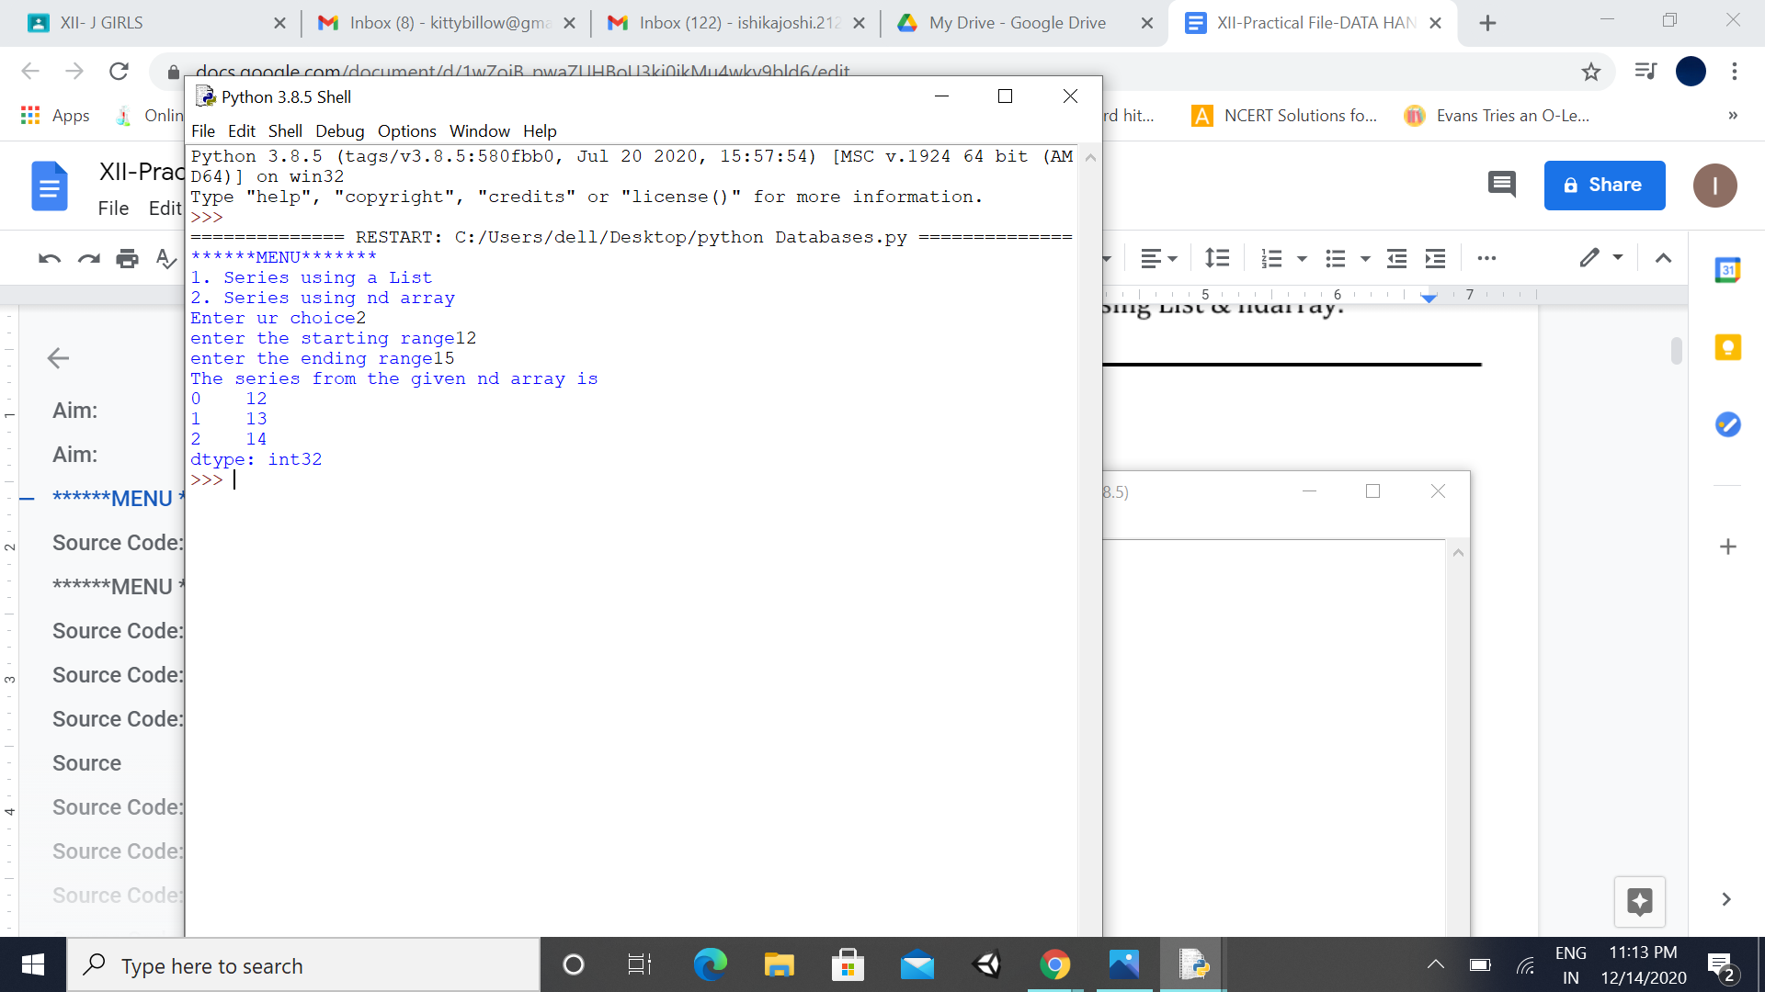

**Date: 26.10.20**

**Program No: 4**

**4. To** **Perform Arithmetic Operations on Entered Series**

.

**Aim:**

Write a program in python to read two list from the user then create two series from the given list and perform arithmetic operations (+, -, *, /) on these series.

**Source Code:**

import pandas as pd

import numpy as np

a=list()

n=int(input("Enter the size of the list"))

print("Enter the elements in the first list")

for i in range(0,n):

num=int(input("Enter number:"))

a.append(num)

print("The series from the given list is ")

s1=pd.Series(a)

print(s1)

b=list()

print("Enter the elements in the second list")

for i in range(0,n):

num=int(input("Enter number:"))

b.append(num)

print("The series from the given list is ")

s2=pd.Series(b)

print(s2)

print('The sum of the above two series is ')

print(s1+s2)

print('The difference of the above two series is ')

print(s1-s2)

print('The product of the above two series is ')

print(s1*s2)

print('The quotients of the above two series is ')

print(s1/s2)

**Output:**

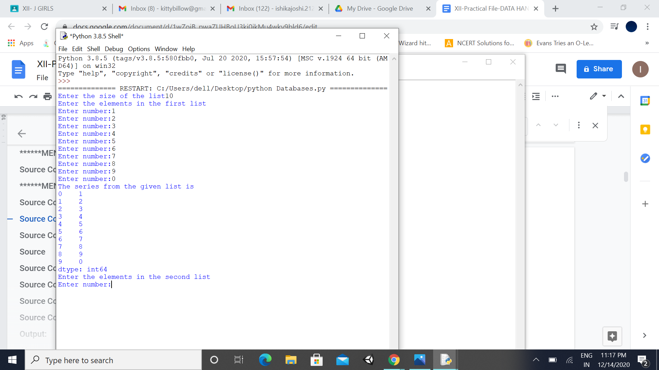

**5.** Program to create Series and print it in reverse order. Also print alternate elements in the Series.

**Program No: 5**

**Date: 27.10.20**

**Aim:**

Write a program in python to read a list from the user and create a series from the given list then perform the following operations:

* Print the series in reverse order
* Print alternate elements in the series

**Source Code:**

import pandas as pd

a=list()

n=int(input("Enter the size of the list"))

print("Enter the numbers in the list")

for i in range(0,n):

num=int(input("Enter number:"))

a.append(num)

b=list()

print("Enter the index of elements")

for i in range(0,n):

num1=int(input("Enter the index:"))

b.append(num1)

print("The series from the given list is ")

s=pd.Series(a,b)

print(s)

print ('The series in reverse order')

print(s[::-1])

print('The alternate elements are')

print(s[0:n:2])

**Output:**

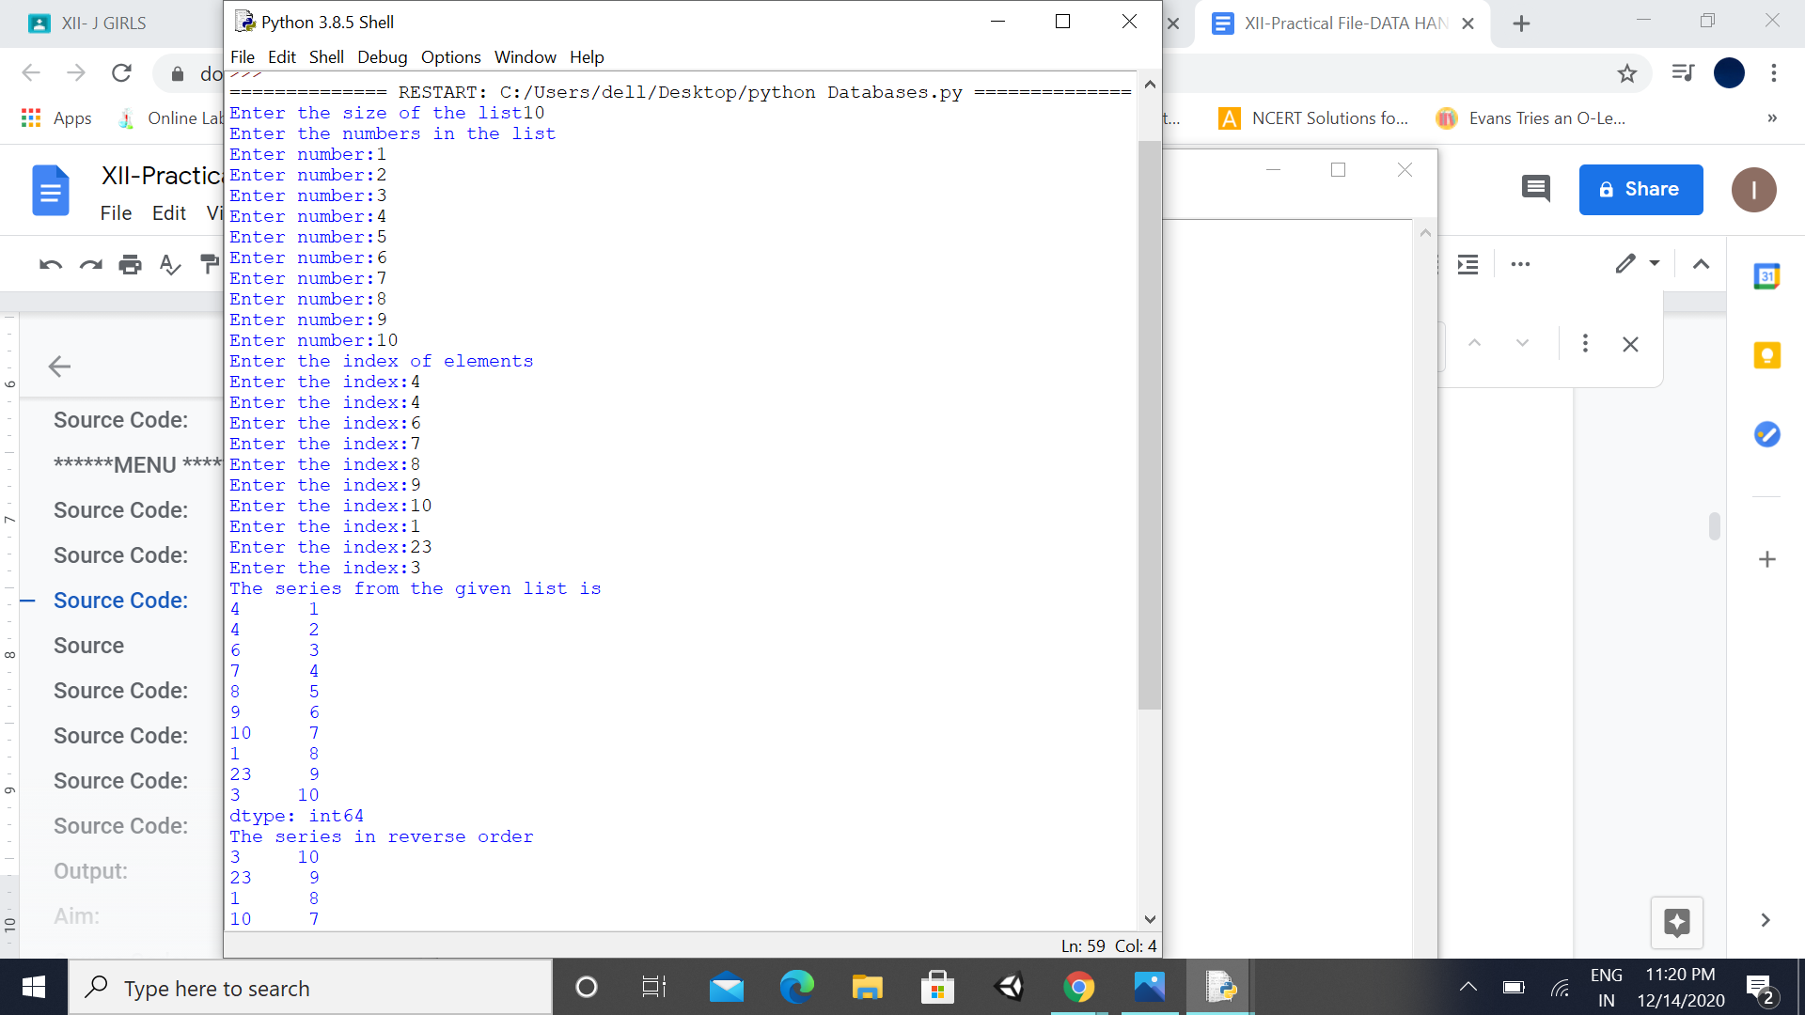

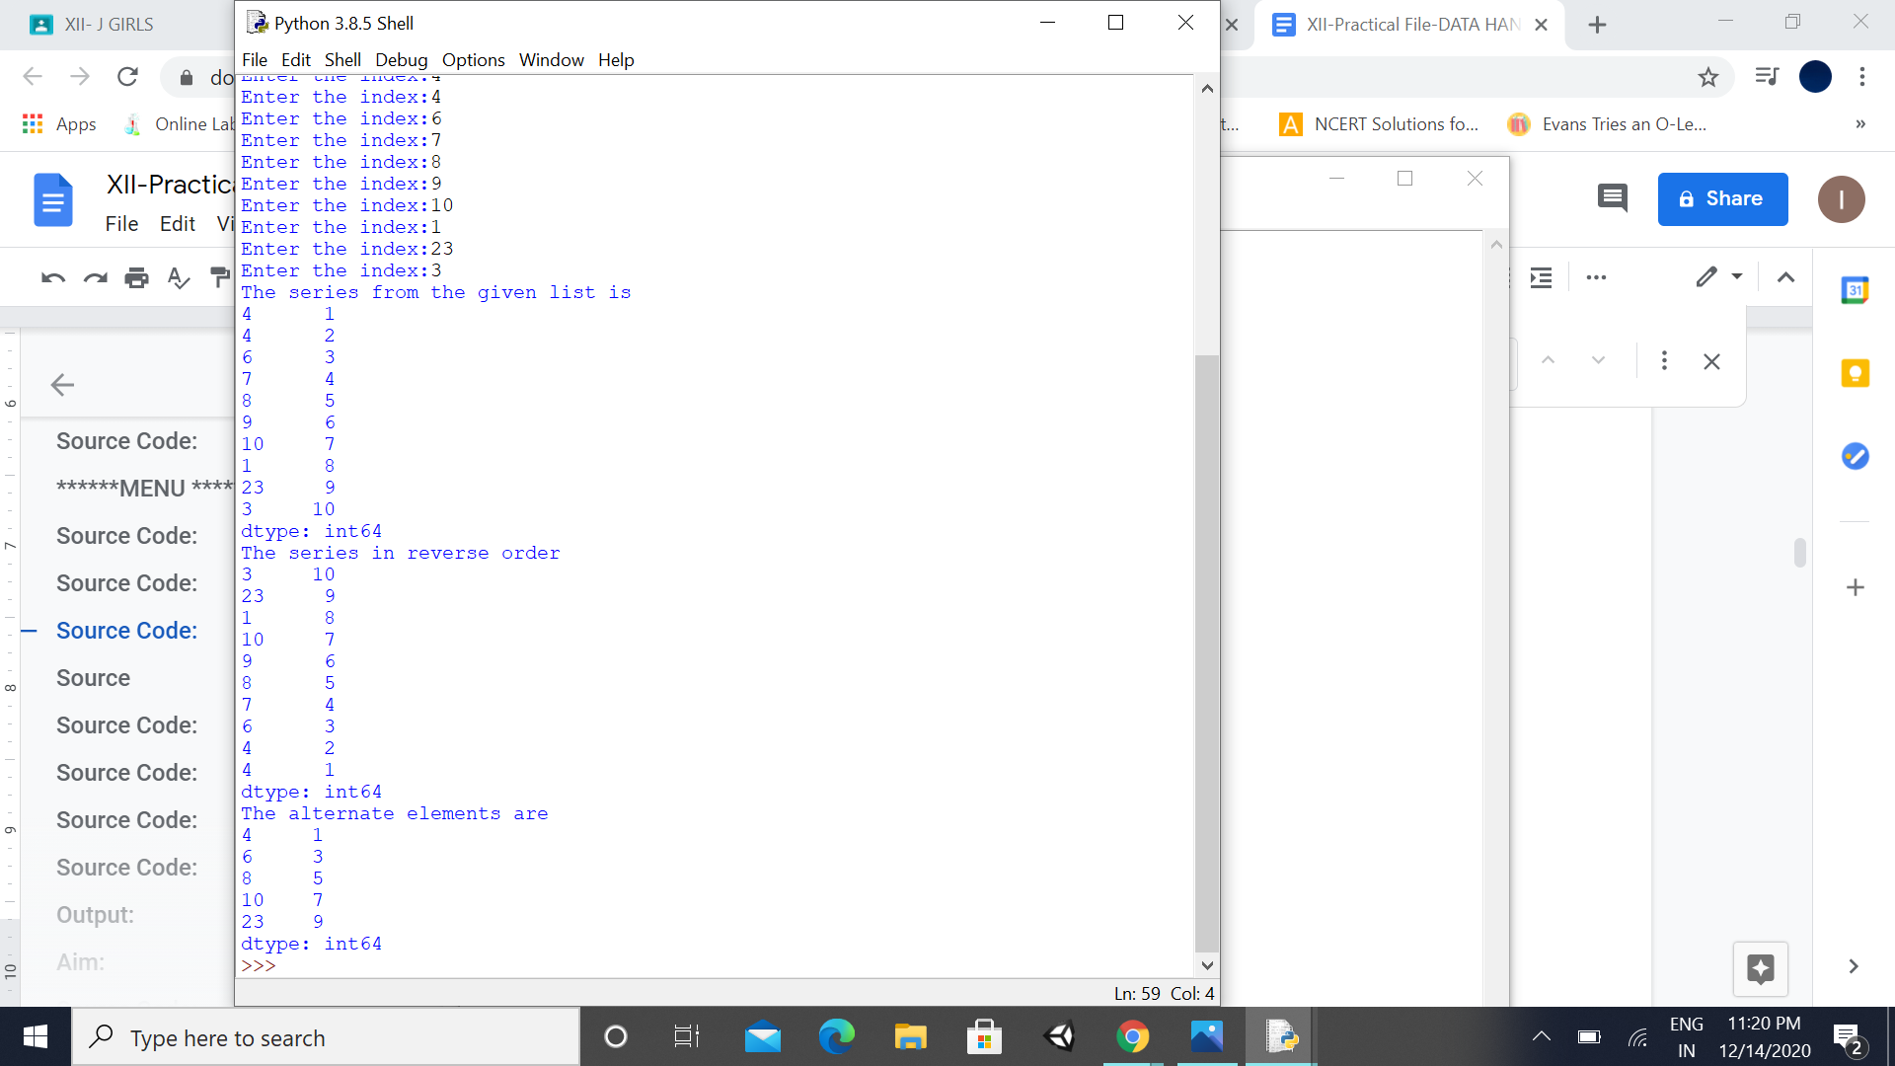

**6. Program to Add new element into a Series / Delete element from Series**.

**Program No: 6**

**Date: 28.10.20**

**Aim:**

Write a program in python to create a series using a list and perform the following operation depends on user’s choice. The choices are:

MENU

1. Add new element into the series

2. Delete element from the series

**Source**

import pandas as pd

print("Read and print a list from user:")

a=list()

n=int(input("Enter the size of the list"))

print("Enter the numbers in the list")

for i in range(0,n):

num=int(input("Enter number:"))

a.append(num)

b=list()

print("Enter the index of elements")

for i in range(0,n):

num1=int(input("Enter the index:"))

b.append(num1)

print("The series from the given list is ")

s=pd.Series(a,b)

print(s)

choice='y'

while(choice=='y' or choice=='Y'):

print("******MENU*******")

print("1. Add new elements into the series")

print("2. delete elements from the series")

c=int(input("Enter ur choice"))

if(c==1):

value=int(input("enter the element to be added "))

index=int(input('enter the index'))

s[index]=value

print("the modified series is")

print(s)

elif(c==2):

ind=int(input("give the index to be deleted"))

s.drop([ind],inplace=True)

print("the modified series is")

print(s)

else:

print('Invalid choice')

choice=input('do u want to continue type [y/Y]')

**Output:**

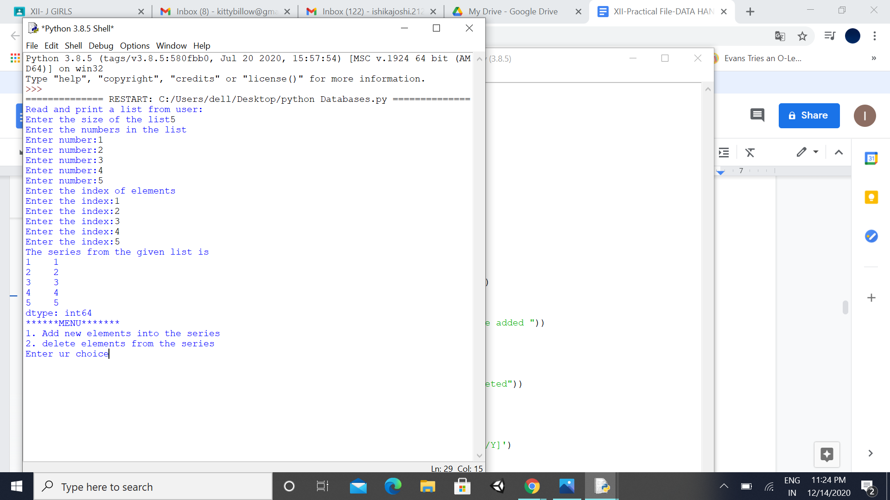

7. To Compare the Elements of the 2 Given Pandas Series

**Program No: 7**

**Date: 2.11.20**

**Aim:**

Write a Pandas program to compare the elements of the two given Pandas Series.

**Source Code:**

import pandas as pd

ds1= pd.Series([2, 4, 6, 8, 10])

ds2= pd.Series([1,3, 5, 7,10])

print("Series1:")

print(ds1)

print("Series2:")

print(ds2)

print("Compare the elements of the said Series:")

print("Equals:")

print(ds1 == ds2)

print("Greater than:")

print(ds1 > ds2)

print("Less than:")

print(ds1 < ds2)

**Output:**

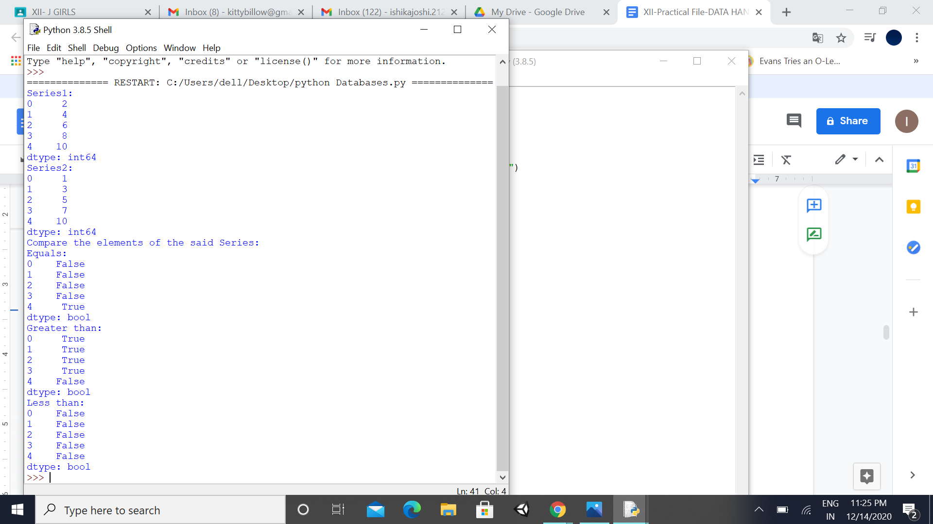

**8. To display first and last two rows of the given Series.**

**Program No: 8**

**Date: 3.11.20**

**Aim:**

To display first two and last two rows of series given below:

a 10

b 20

c 30

d 40

e 50

dtype: int64

**Source Code:**

#Using head() and tail() functions on series

import pandas as pd

series1 =pd.Series([10,20,30,40,50],index=['a','b','c','d','e'])

print(series1)

print(series1.head(2))

print(series1.tail(2))

**Output:**

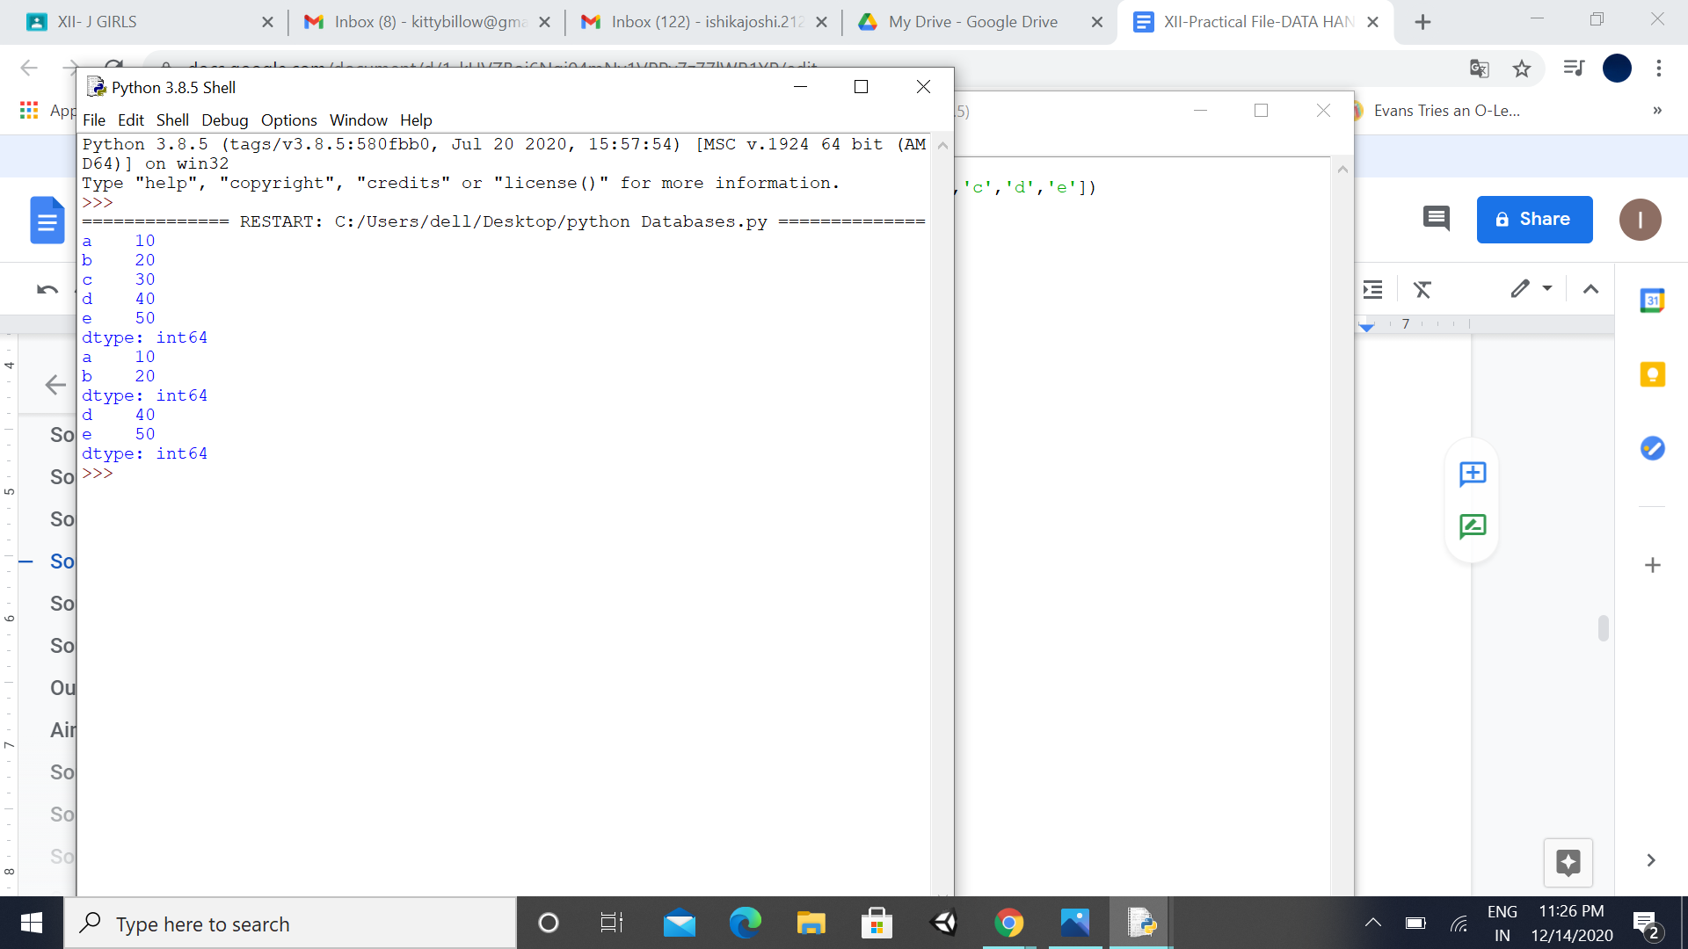

**9. To select rows based on the given condition from a given data frame.**

**Program No: 9**

**Date: 4.11.20**

**Aim:**

Write a Pandas program to select the rows where the height is not known, i.e. is NaN.

**'name': ['Asha', 'Radha', 'Kamal', 'Divya', 'Anjali'],**

**'height': [ 5.5, 5, np.nan, 5.9, np.nan],**

**'age': [11, 23, 22, 33, 22]**

**Source Code:**

import pandas as pd

import numpy as np

pers_data = {'name': ['Asha', 'Radha', 'Kamal', 'Divya','Anjali'],

'height': [ 5.5, 5, np.nan, 5.9, np.nan],

'age': [11, 23, 22, 33, 22]}

labels = ['a', 'b', 'c', 'd', 'e']

df = pd.DataFrame(pers_data , index=labels)

print("Persons whose height not known:")

print(df[df['height'].isnull()])

**Output:**

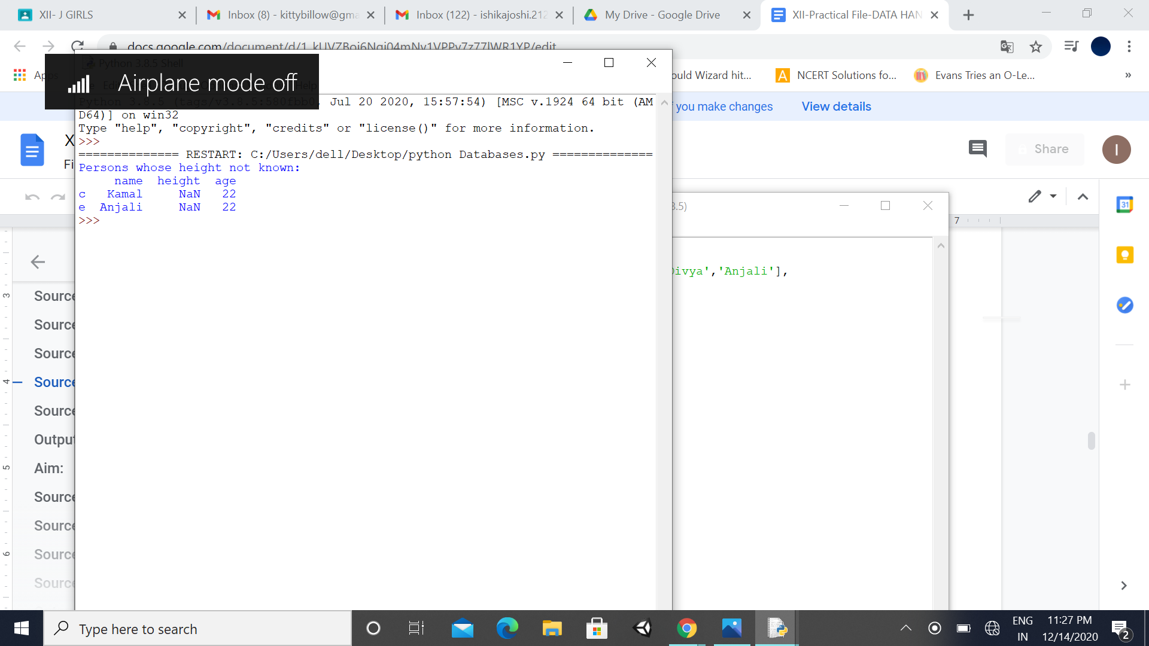

**Program No: 10**

**10. To select data from data frame on the basis of given condition.**

.

**Date: 9.11.20**

**Aim:**

Write a Pandas program to select the name of persons whose height is between 5 to 5.5 (both values inclusive).

**'name': ['Asha', 'Radha', 'Kamal', 'Divya', 'Anjali'],**

**'height': [ 5.5, 5, np.nan, 5.9, np.nan],**

**'age': [11, 23, 22, 33, 22]**

**Source Code:**

import pandas as pd

import numpy as np

pers_data = {'name': ['Asha', 'Radha', 'Kamal', 'Divya','Anjali'],

'height': [ 5.5, 5, np.nan, 5.9, np.nan],

'age': [11, 23, 22, 33, 22]}

labels = ['a', 'b', 'c', 'd', 'e']

df = pd.DataFrame(pers_data , index=labels)

print("Persons whose height is between 5 and 5.5")

print(df[(df['height']>= 5 )& (df['height']<= 5.5)])

**Output:**

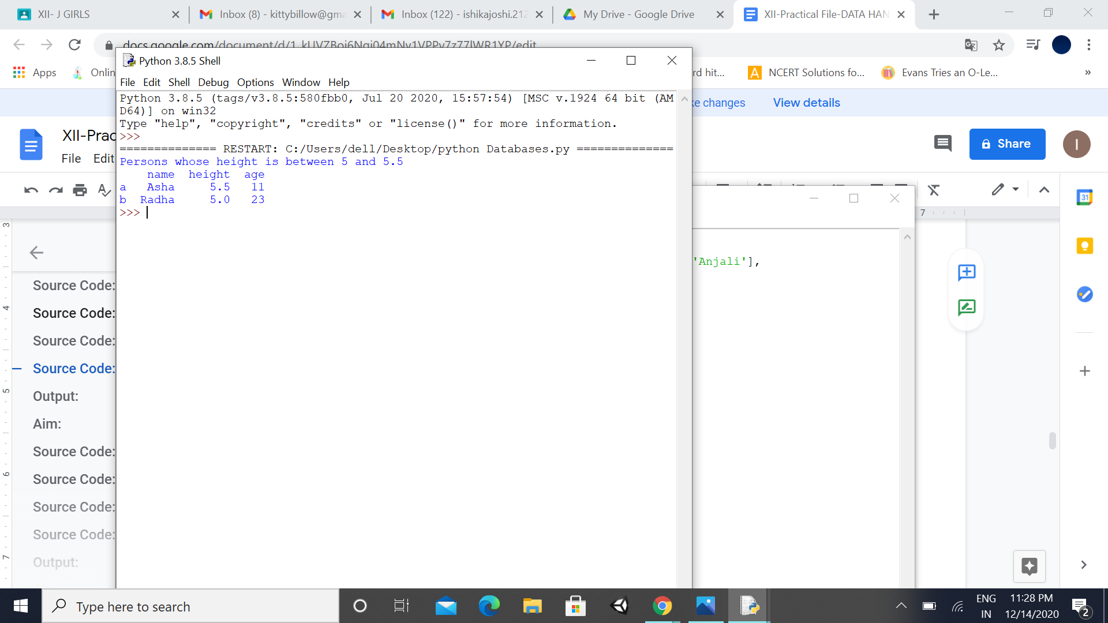

**Program No: 11**

**11. To create data frame, add new columns in it, after creating and adding values to it.**

.

**Date: 10.11.20**

**Aim:**

Write a program to create data frame for 3 student including name and roll numbers and add new columns for 5 subjects and 1 column to calculate percentage. It should include random numbers in marks of all subjects

**Source Code:**

import pandas as pd, numpy as np, random

D={'Roll':[1,2,3],'Name':['Sangeeta','Shanti','Swati']}

P=[]

C=[]

M=[]

E=[]

H=[]

SD=pd.DataFrame(D,index=[1,2,3])

for i in range(3):

P.append(random.randint(1,101))

C.append(random.randint(1,101))

M.append(random.randint(1,101))

E.append(random.randint(1,101))

H.append(random.randint(1,101))

SD['Phy']=P

SD['Chem']=C

SD['Maths']=M

SD['Eng']=E

SD['Hin']=H

SD['Total']=SD.Phy+SD.Chem+SD.Maths+SD.Eng+SD.Hin

SD['Per']=SD.Total/5

print(SD)

**Output:**

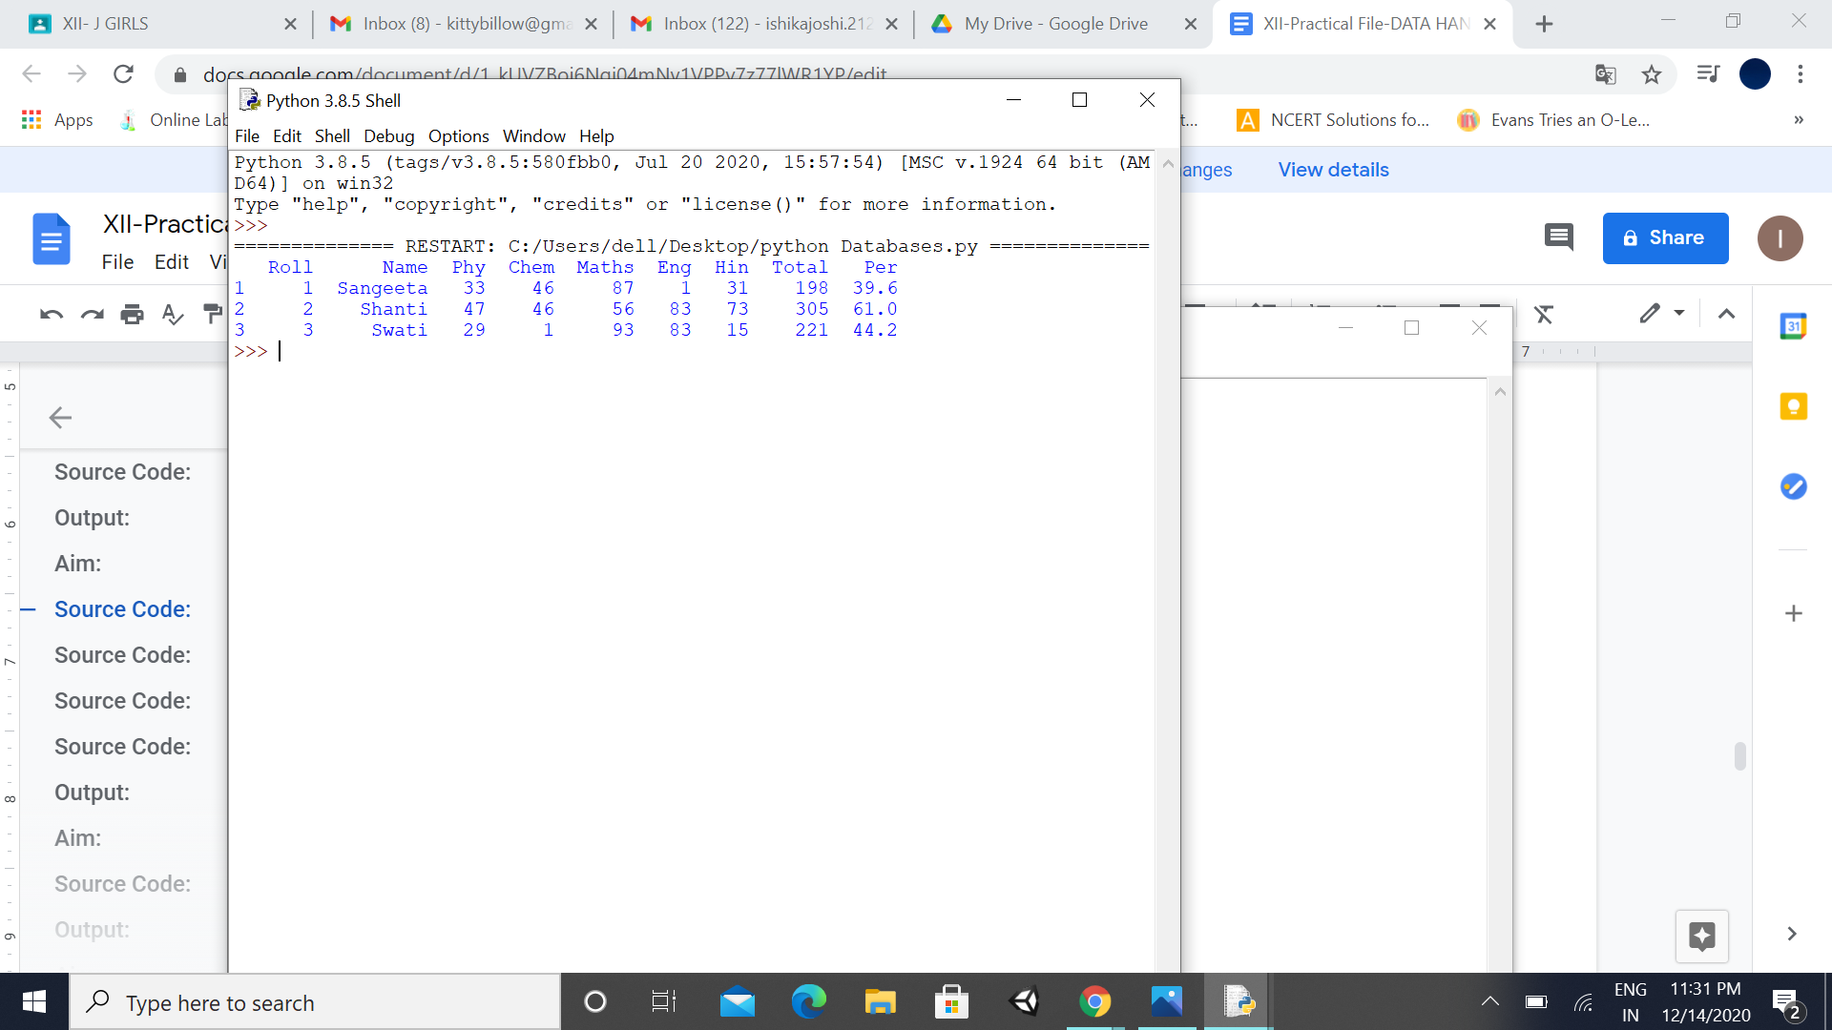

**12. To print the Data Frame df, one row at a time.**

**Program No: 12**

**Date: 11.11.20**

**Aim:**

To create a program in python to print the Data Frame df, one row at a time.

**Source Code:**

import pandas as pd

dict = {'name':["Aashi", "Pankaj","George"],

'degree': ["MBA", "BCA","MBA"]}

df = pd.DataFrame(dict,index=['RNO 1','RNO 2','RNO 3'])

print("Given Dataframe is:")

print(df)

print('______________________________')

for i, j in df.iterrows():

print(j)

print('______________________________')

**Output:**

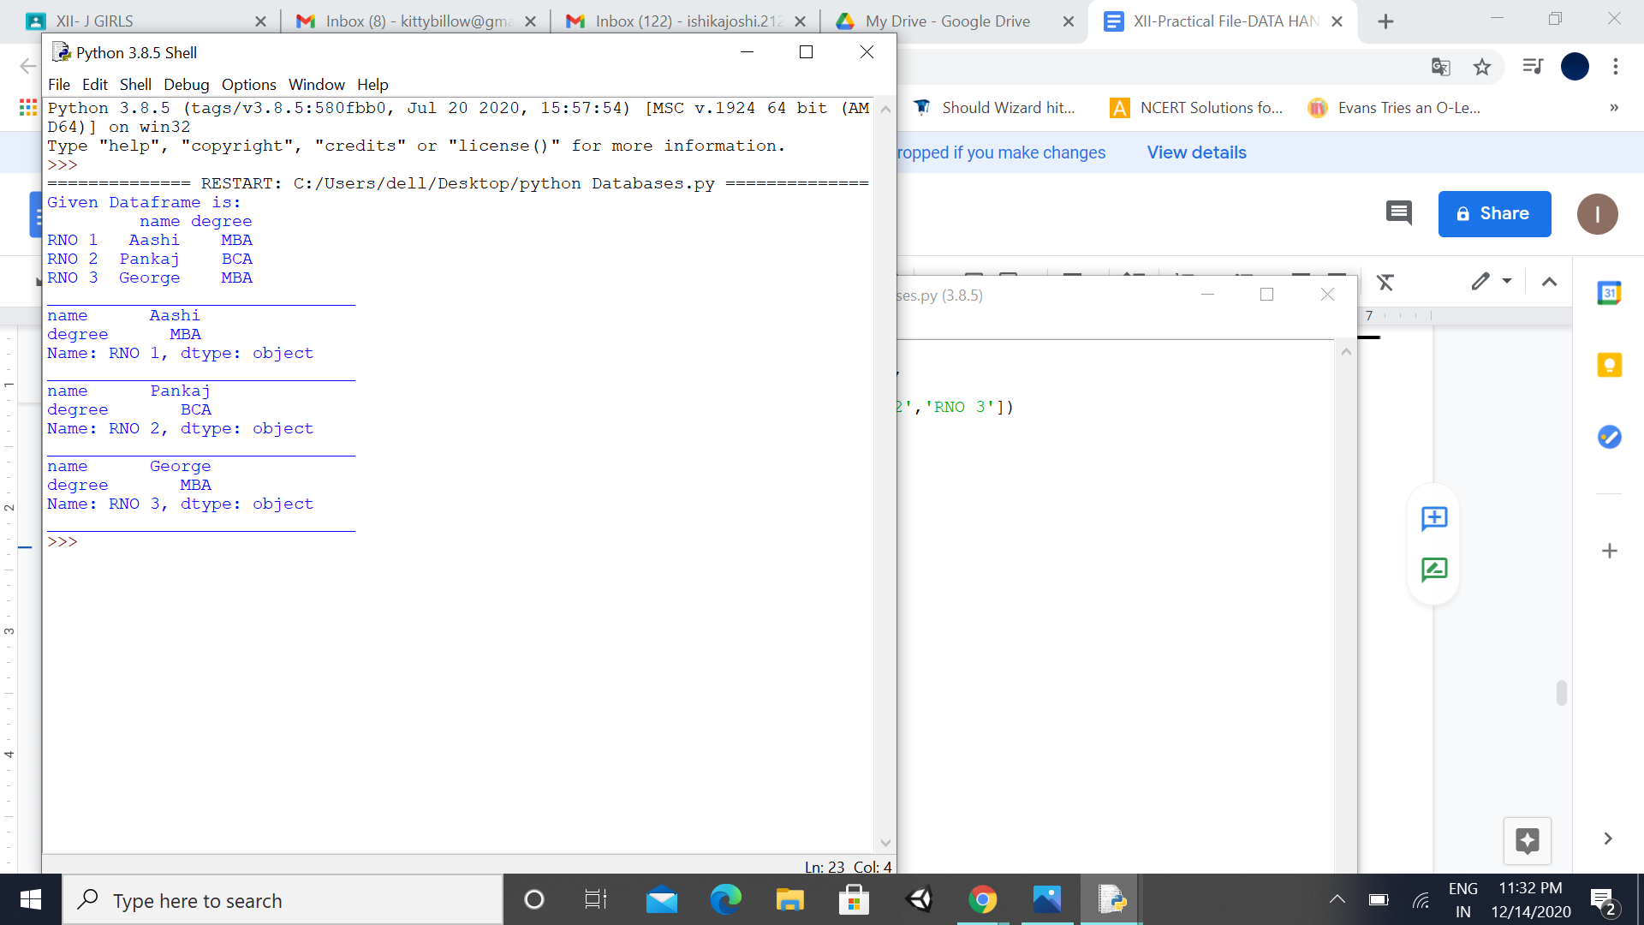

**Program No: 13**

**13. To print the Data Frame df, one column at a time.**

**of water in daily life.**

**Date: 17.11.20**

**Aim:**

To create a program in python to print the Data Frame df, one column at a time.

**Source Code:**

import pandas as pd

dict = {'name':["Aashi", "Pankaj","George"],

'degree': ["MBA", "BCA","MBA"]}

df = pd.DataFrame(dict,index=['RNO 1','RNO 2','RNO 3'])

print("Given Dataframe is:")

print(df)

print('______________________________')

for i, j in df.iteritems():

print(j)

print('______________________________')

**Output:**

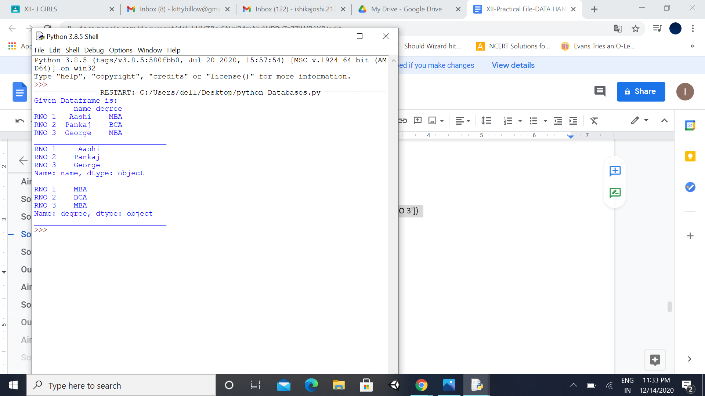

**Program No: 14**

**14. To read data from .csv file to Data Frame.**

**Date: 18.11.20**

**Aim:**

Write a program to read the records from STUD_NEW.csv (shown below) in data frame & print it.

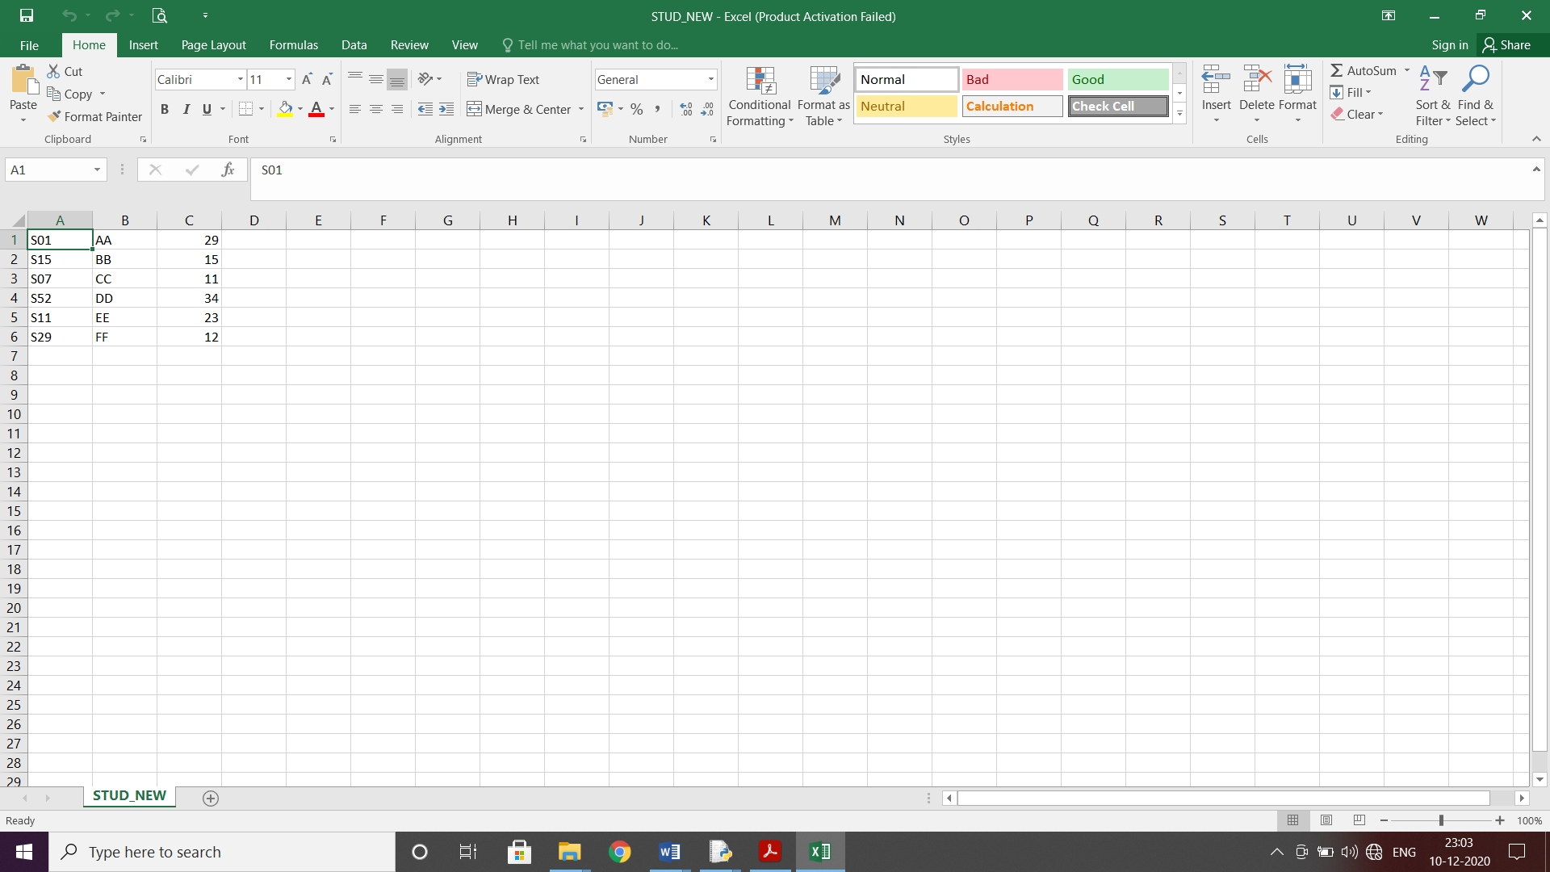

**Source Code:**

import pandas as pd

df=pd.read_csv("D:\Excel_Data\STUD_NEW.csv",names=["REGNO","STUD NAME","CLASS"])

print(df)

**Output:**

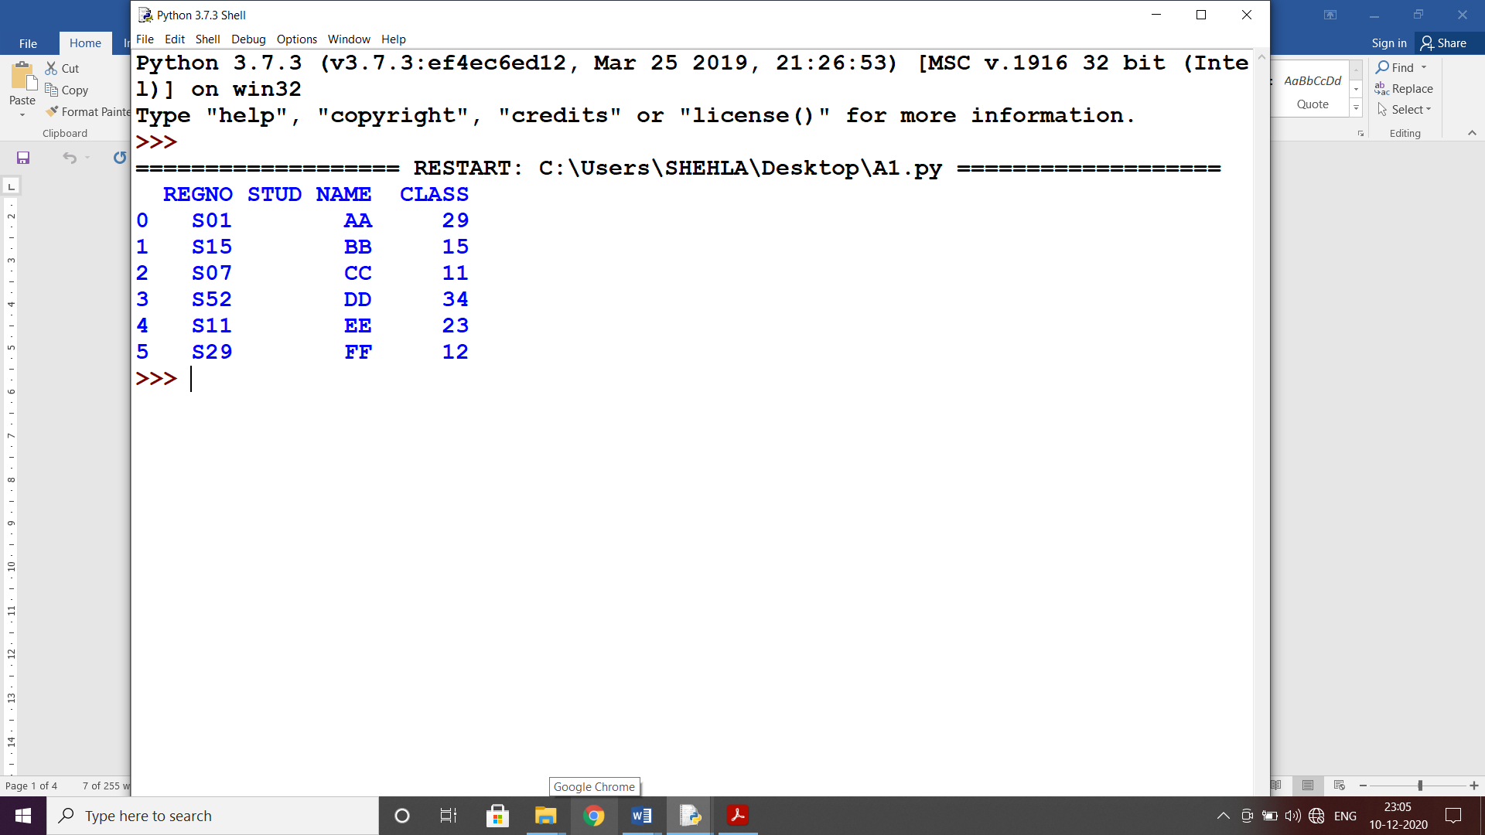

**Program No: 15**

**15. To store data from Data Frame to .csv file**

.

**Date: 19.11.20**

**Aim:**

Write a program to store the data of data frame df in a csv file along with NaN values stored as ‘ABSENT’.

**Source Code:**

import pandas as pd

import numpy as np

d={'SchNo':['SR01','SR12','SR85','RG29'],

'Name':['Avani','Meet','Zaid','Peter'],

'Per':[89.5,np.NaN,65.7,np.NaN]}

df=pd.DataFrame(d)

print(df)

df.to_csv("D:\\Excel_Data\\s3.csv",na_rep="ABSENT")

**Output:**

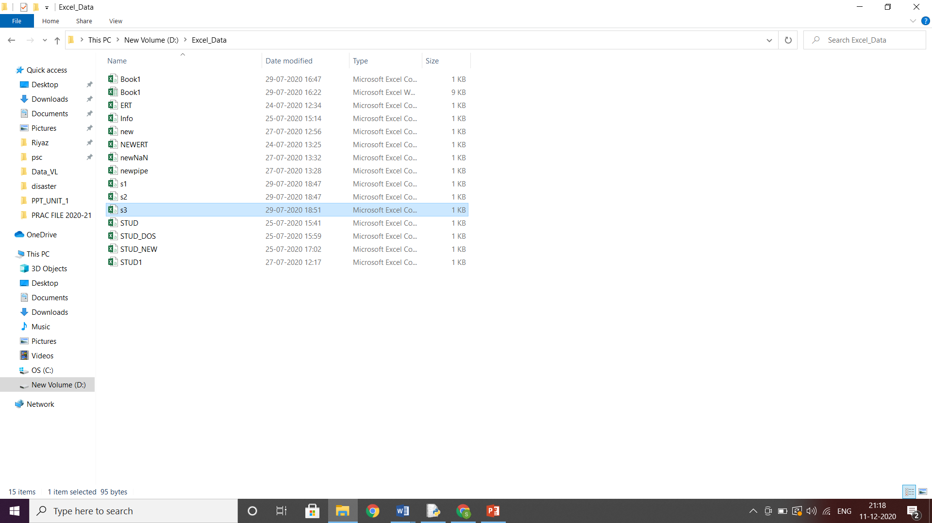

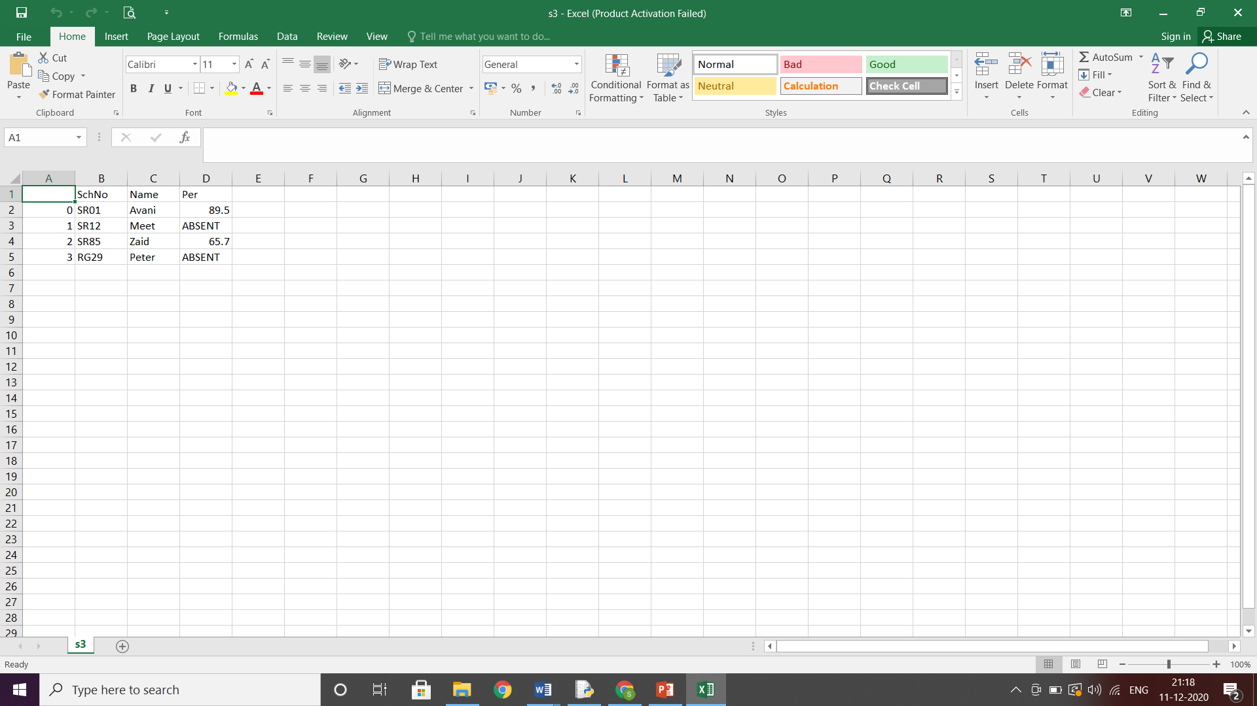

**Program No: 16**

**16. To plot a bar chart to display the result of a school for five consecutive years.**

**Date: 21.11.20**

**Aim:**

To create a program to plot a bar chart in python to display the result of a school for five consecutive years.

**Source Code:**

import matplotlib.pyplot as pl

year=['2015','2016','2017','2018','2019'] # list of years

p=[98.50,70.25,55.20,90.5,61.50] #list of pass percentage

j=['b','g','r','m','c'] # color code of bar charts

pl.bar(year, p, width=0.2, color=j) # bar( ) function to create the bar chart

pl.xlabel("year") # label for x-axis

pl.ylabel("Pass%") # label for y-axis

pl.show( ) # function to display bar chart

**Output:**

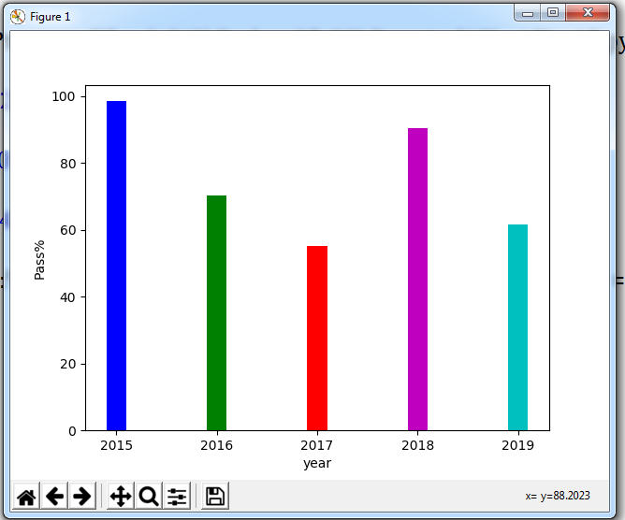

**Date: 01.12.20**

**Program No: 17**

**17. To plot a graph for the function y = x2**

**Aim:**

To create a program in python to plot a graph for the function y = x2

**Source Code:**

import matplotlib.pyplot as pl

import numpy as np

x= np.linspace(-50,50)

y= x**2

pl.plot(x,y,linestyle='-')

pl.show( )

**Output:**

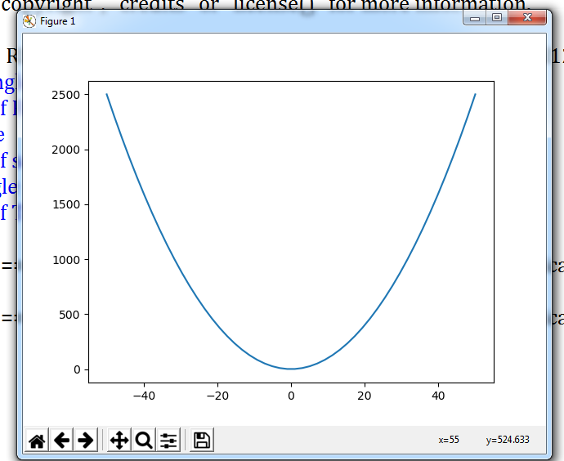

**Program No: 18**

**18. To plot a histogram for given data.**

queue.

.

**Date: 2.12.20**

**Aim:**

Draw the histogram based on the Production of Wheat in different Years:

**Year: 2000,2002,2004,2006,2008,2010,2012,2014,2016,2018**

**Production: 4,6,7,15,24,2,19,5,16,4**

**Source Code:**

import pandas as pd

import matplotlib.pyplot as plt

data={'Year':[2000,2002,2004,2006,2008,2010,2012,2014,2016,2018],

'Production':[4,6,7,15,24,2,19,5,16,4]}

d=pd.DataFrame(data)

print(d)

x=d.hist(column='Production',bins=5,grid=True)

plt.show()

**Output:**

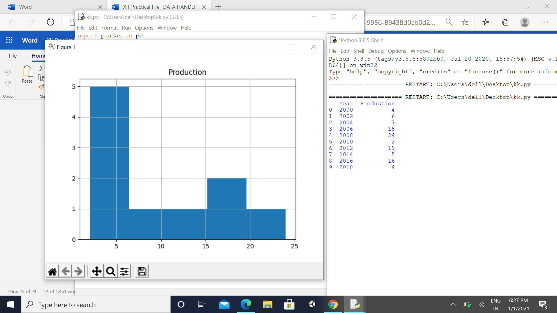

**Program No: 19**

**Date: 3.12.20**

**19. To plot a bar chart for the given data.**

**Aim:**

The number of students in 7 different classes is given below. Represent this data on the bar graph.

**Class: 6th 7th 8th 9th 10th 11th 12th**

**Number of Students: 130 120 135 130 150 80 75**

**Source Code:**

import matplotlib.pyplot as pl

cl=[6,7,8,9,10,11,12]

s=[130,120,135,130,150,80,75]

pl.bar(cl,s)

pl.xlabel("Class")

pl.ylabel("Class Strength")

pl.show()

**Output:**

